**CSE 422: Artificial Intelligence**

**Assignment 1**

**Total Marks: 80**

**(Each question carries 20 marks)**

**1.** For the graph below and the heuristic function given S is the starting

node and T is the goal node. Now,

1. Use the GBFS algorithm on the graph to find the optimal path.
2. Use the A* algorithm on the graph to find the optimal path.
3. Is the heuristic consistent? Explain with necessary calculations.
4. Is the heuristic admissible? Explain with necessary calculations.

Note: If any tie occurs, expand the node that comes first alphabetically.

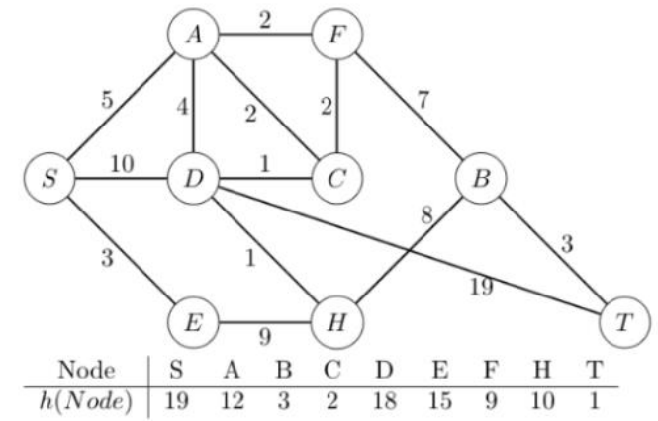

**2.** Observe the figure below and answer the following,

1. What kind of problem a hill climb search might face if it starts at point A and goes left to right?
2. What kind of problem a hill climb search might face if it starts at point B and goes right to left?
3. What steps can be taken to solve the problems?
4. Briefly describe Simulated Annealing, its advantages and disadvantages. Explain how it works and solve the problems of hill climb search.

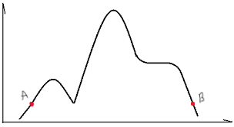

**3.** Assume [X1, X2, X3, X4, X5, X6, X7, X8] represents a set of 8 numbers where each number can be anything from 1 to 100. Now your task is to find such a set with a combination of numbers where the difference between the sum of the even numbers and the sum of the odd numbers is 30. And you have to solve this problem using Genetic Algorithm. So, for e.g., if D1 represents the sum of the odd numbers and D2 represents the sum of the even numbers then (D1 - D2) or (D2 - D1) will be equal to 30 for the solution.

1. Encode the problem and deduce two parent chromosomes, PC1 and PC2. But

for PC1, the value of X1 should be 100, and for PC2 the value of X1 should

be 1.

1. Define a suitable fitness function for the problem and calculate the fitness of

PC1 and PC2.

1. Illustrate single point crossover after X4 between PC1 and PC2, and then

perform mutation. You can mutate a number of your choosing. Finally,

calculate the fitness of the two newly formed child chromosomes and comment

on which child is fitter.

**4.** Look at the tree below and answer the following,

1. If you apply the min-max algorithm, what values will be assigned to A, B, C, D, E, F, and G?
2. What will be the alpha and beta values of each node in this tree if alpha-beta pruning is run on this tree? Also, illustrate the crossed-out branches that would be pruned by alpha-beta pruning. Show the complete simulation for the alpha-beta pruning algorithm.
3. Analyze the difference between the results a and b. What advantage(s)/disadvantage(s) are found after applying the alpha-beta pruning algorithm?

